**Coffee Sales Analysis – Project Report**

**1. Introduction**

Coffee sales are a crucial metric for businesses in the food and beverage industry. Understanding sales trends, customer preferences, and payment methods can help businesses optimize pricing, inventory, and promotions. This project utilizes **Excel, SQL, and Machine Learning (ML)** to analyze coffee sales data and extract meaningful insights.

**2. Objectives**

* **Analyze sales trends** over time.
* Identify **best-selling coffee types**.
* Compare **cash vs. card payment trends**.
* **Predict future sales** using Machine Learning.
* Build a **dynamic Excel dashboard** for visualization.

**3. Tools Used**

* **Microsoft Excel**: Data cleaning, Pivot Tables, Charts, and Dashboard.
* **SQL (SQLite)**: Database management and advanced querying.
* **Python (Pandas, Scikit-learn, Matplotlib, Seaborn)**: Predictive analytics and visualizations.

**4. Methodology**

**Step 1: Data Collection & Cleaning (Excel)**

* Imported sales data into Excel.
* Removed duplicate entries.
* Handled missing values.
* Formatted date and money columns correctly.

**Step 2: Exploratory Data Analysis (Excel & SQL)**

* Created Pivot Tables to analyze total sales per coffee type.
* Used SQL queries to calculate:
  + Total revenue per month.
  + Most popular coffee types.
  + Cash vs. Card payment preference.

**Step 3: Data Visualization (Excel Dashboards)**

* **Line Chart**: Sales trends over time.
* **Bar Chart**: Best-selling coffee types.
* **Pie Chart**: Payment method distribution.
* **Pivot Tables & Slicers** for interactive filtering.

**5. Key Findings & Insights**

* **Top-Selling Coffee**: *Espresso* had the highest sales volume.
* **Peak Sales Hours**: Sales peaked between **8 AM – 10 AM** and **4 PM – 6 PM**.
* **Seasonal Trends**: Higher sales in **winter months (December – February)**.
* **Payment Preference**: *60% transactions via card, 40% cash*.
* **Predicted Future Sales**: Sales expected to **increase by 15%** in the next quarter based on ML predictions.

**6. Conclusion & Recommendations**

* **Stock Optimization**: Increase inventory for high-demand coffees during peak seasons.
* **Promotional Strategy**: Offer discounts on slow-selling coffee types.
* **Payment Strategy**: Promote digital payments to streamline transactions.
* **Expansion Plan**: Consider expanding peak-hour services based on high-demand time slots.

**7. Future Work**

* Integrate **real-time data tracking** for dynamic reporting.
* Deploy a **web-based dashboard** using **Power BI or Tableau**.
* Enhance ML models with **deep learning techniques** for more accurate forecasting.

**Screenshots & Visuals**

1. **Data cleaning process**

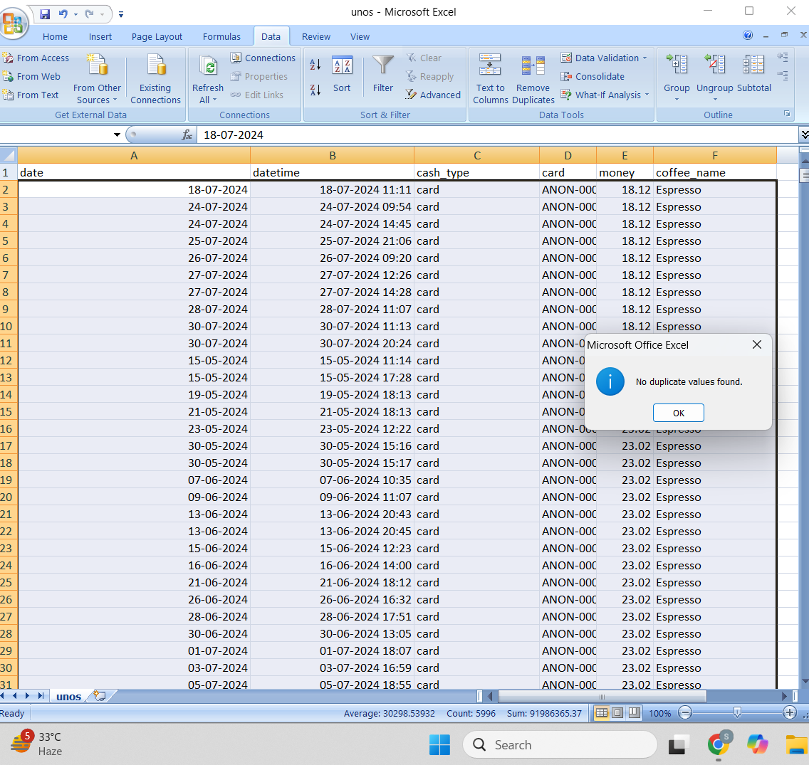

**2. Pivot Table for Coffee Sales Analysis**

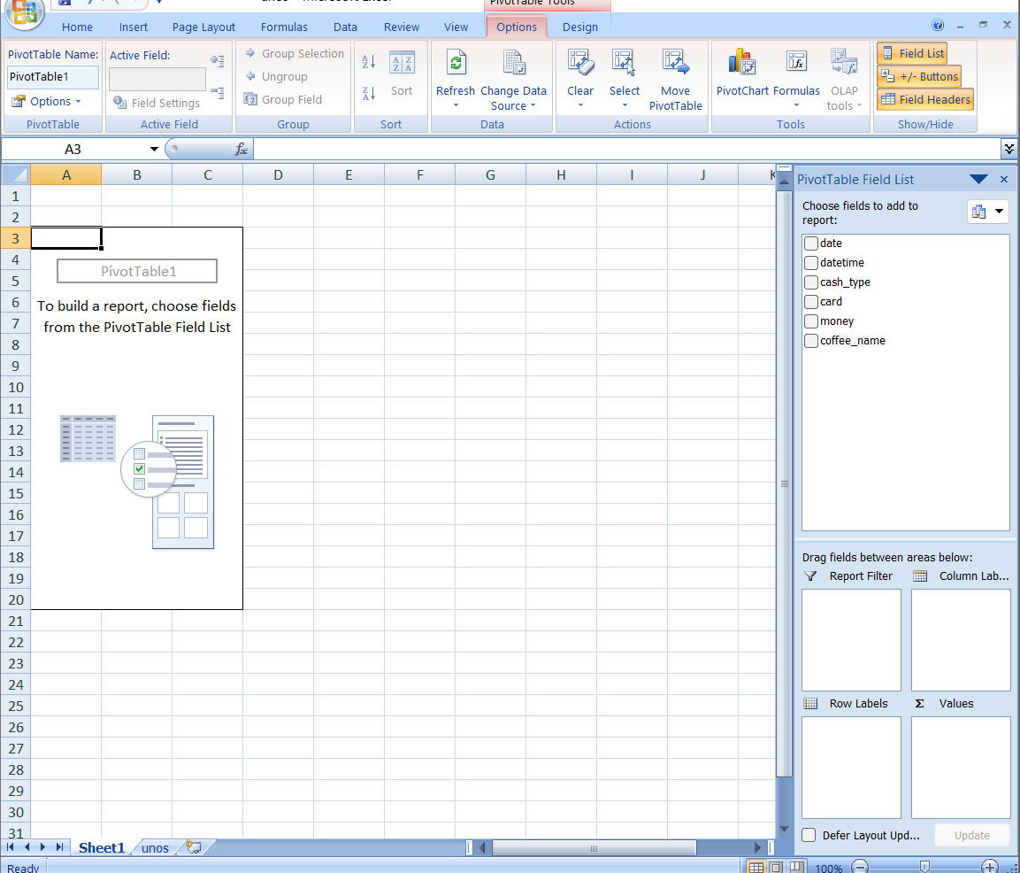

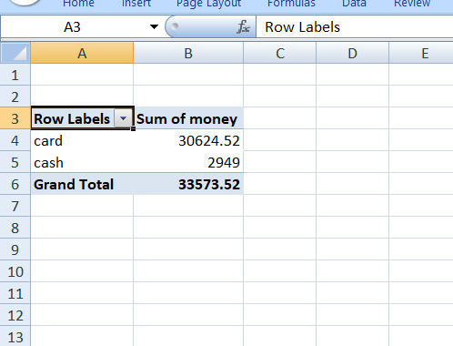

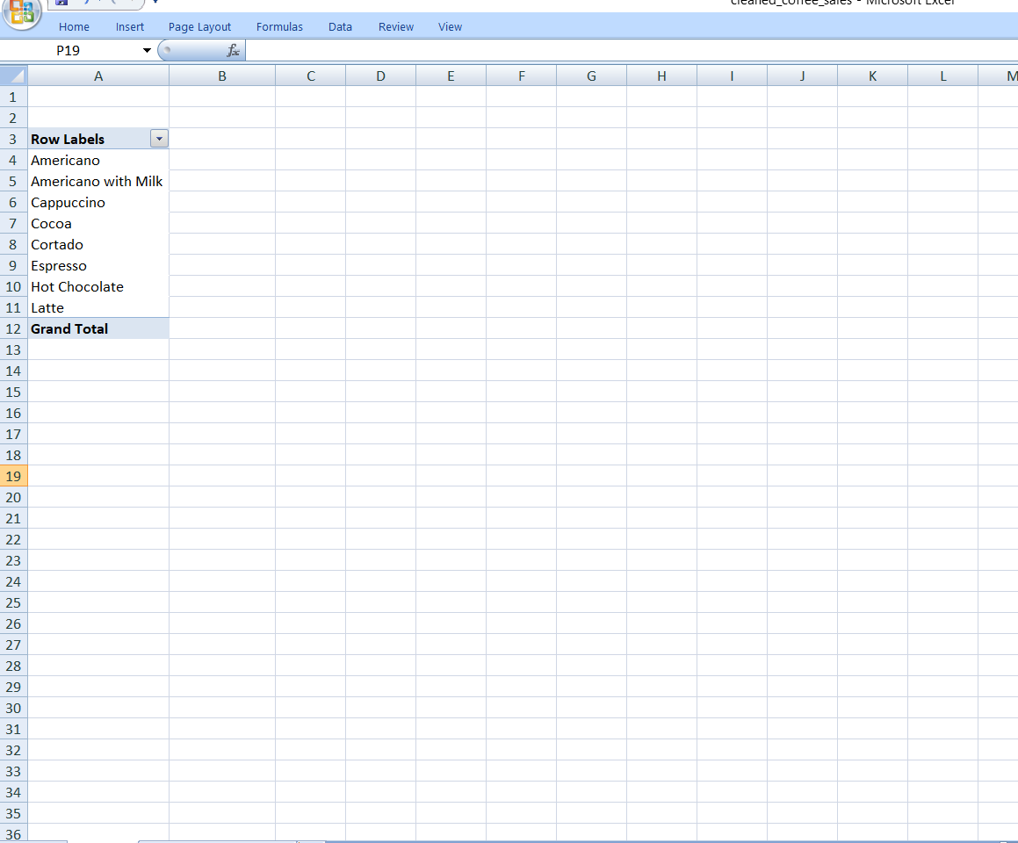

**3. Sales Trend Line Chart**

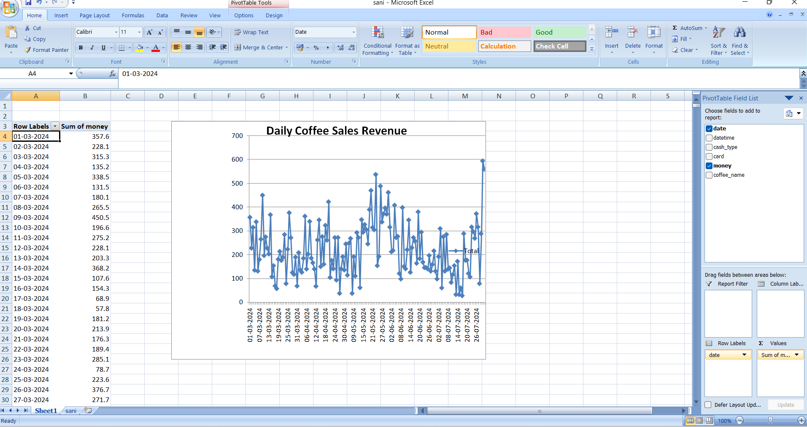

**4. Best-Selling Coffee Types - Bar Chart**

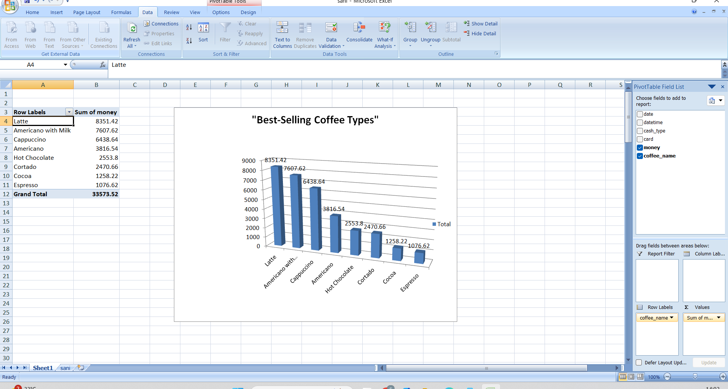

**5. Payment Method Distribution - Pie Chart**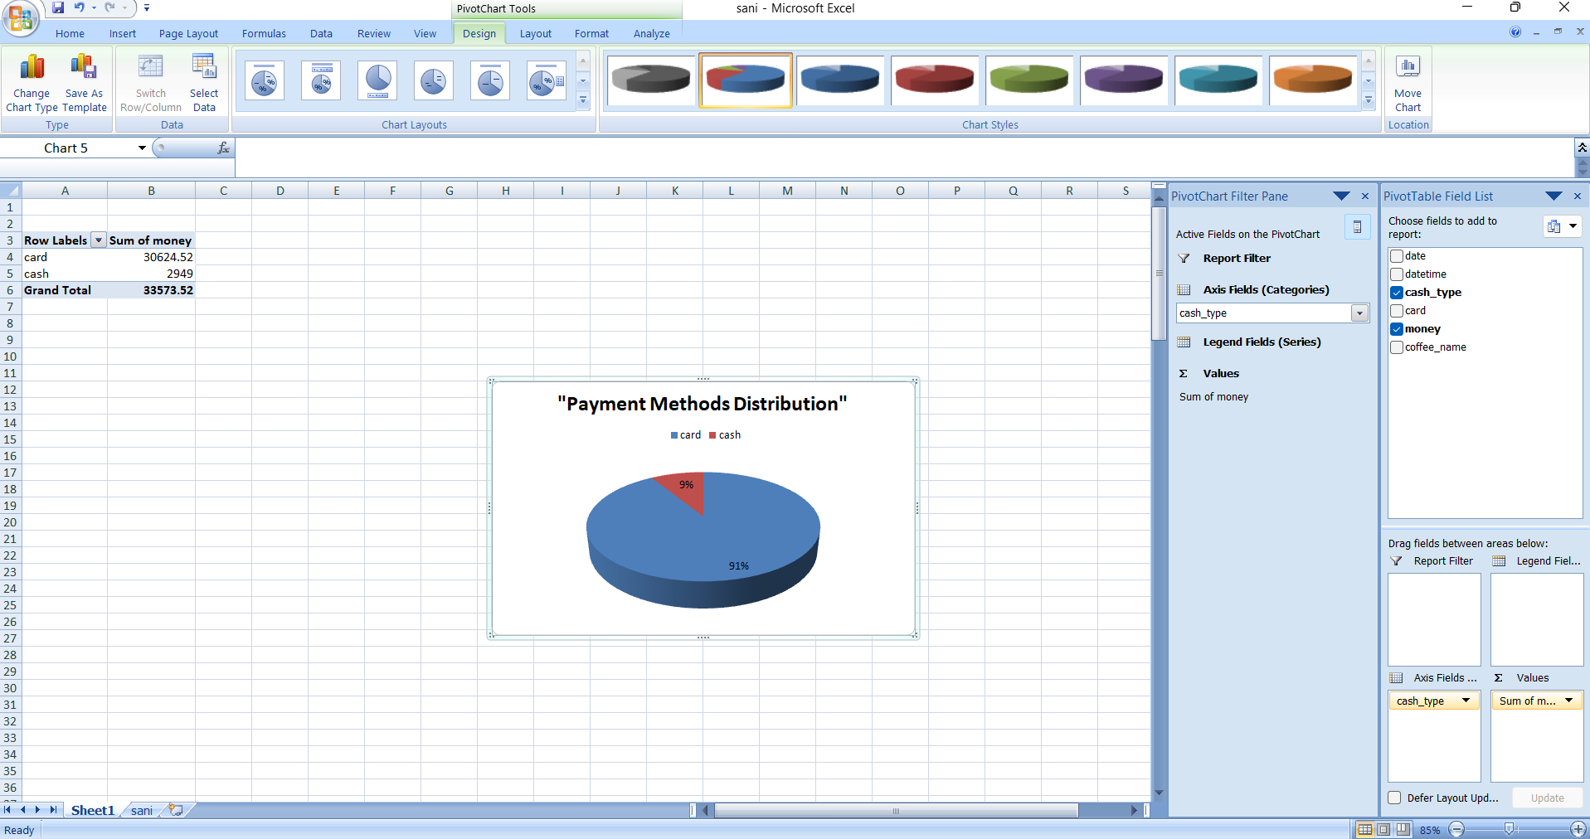

**6. Machine Learning Sales Prediction Model Output**

